湖丽衢二模读后续写学案
- 如何“回应”原文

How can we better echo the original passgae?

- Find the poblems with students’ writing
- Find the problem with setting
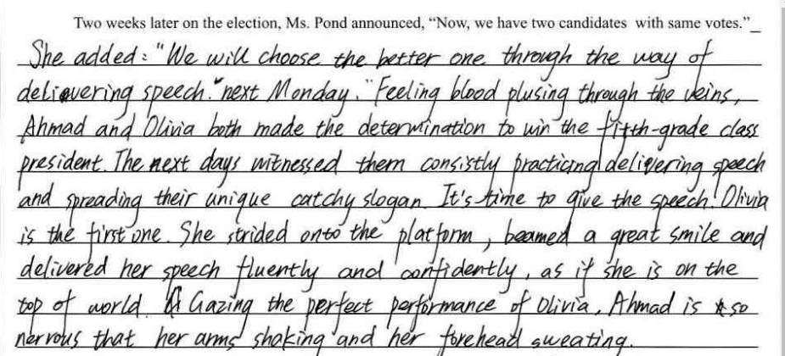

- Find the problem with plot
- Find some foreshadowing in the passage
- Brainstorm: Ahmad’s and Olivia’s creative ideas
Ahmad:
Olivia:

- Find the problem with plot
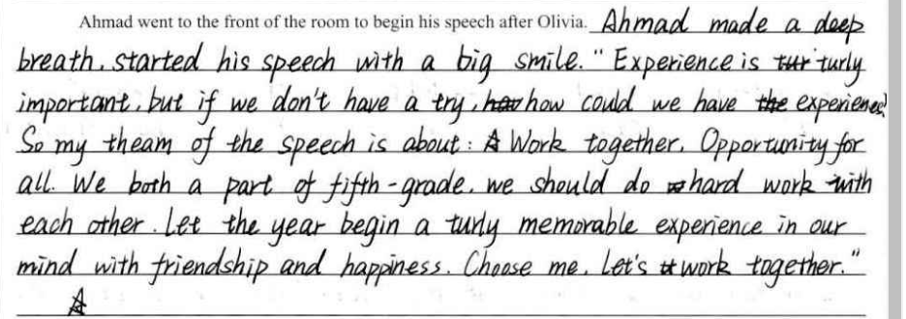

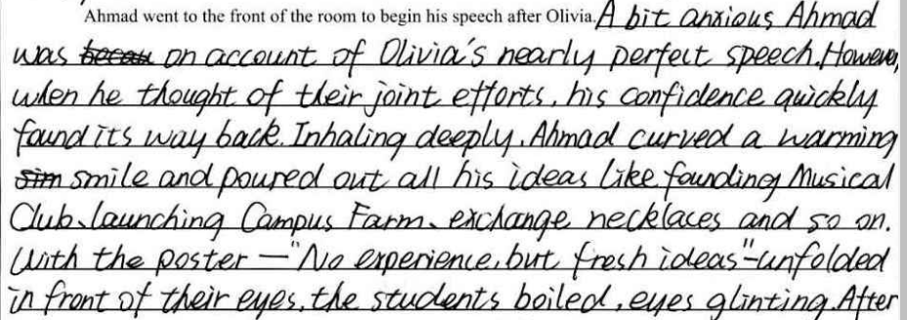

- Find the problem with character
- What are the prsonality traits of the characters? Find some supportive evidence from the text.
- Find the problem with characters
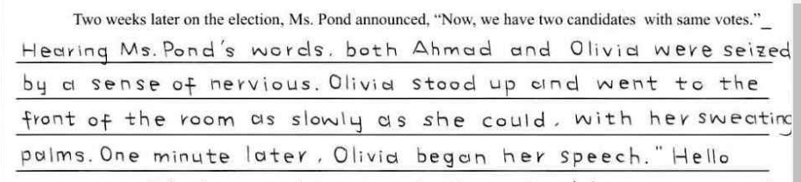

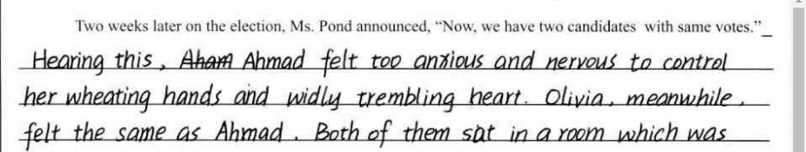

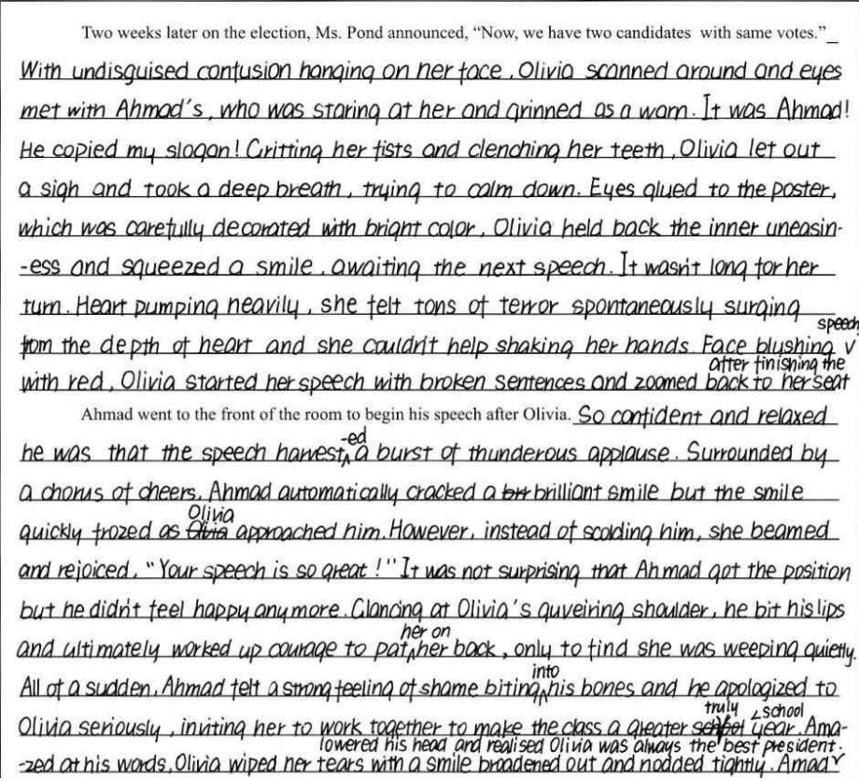

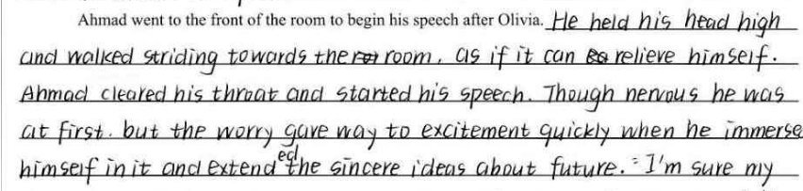

- Find the problem with theme
- What is the theme of this story?
- Find the problem with theme

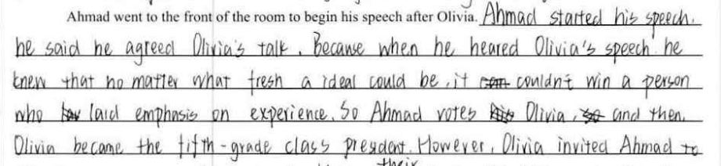

- Rewrite or polish your own writing
- 比赛类可用的语料
表示兴奋（正面描写）：
- When he talked of it, his quiet manner changed, his cold blue eyes sparkled with enthusiasm. 当他谈论这件事的时候，他以往的安静改变了，他冷漠的蓝眼睛闪烁着激情。
- He threw a look of triumph at Summerlee. 他朝Summerlee投去胜利的表情。
- His enthusiasm was catching. 他的热情很有感染力。
- I watched them, fascinated. 我入迷似的盯着他们看。
- His eyes glittered with excitement. 他的眼睛闪着兴奋的光芒。
- Challenger puffed out his chest and seemed to glow with pleasure.
Challenger挺起胸脯，看上去容光焕发。
- a burst of excitement/thrill appears on her face. 她脸上露出激动的表情
- But my stomach was fluttering with excitement and fear. 但我内心翻滚着兴奋与害怕。
- I felt a flicker of fear again. But my excitement took over.
我又感受到了一阵恐惧感闪过。但是我内心的兴奋占据了主导。(表示情绪的转换)
- I couldn’t help feeling a glow of pride. 我情不自禁感受到一股自豪感。
- The excitement built up inside of me as breakfast went on.
随着早餐的进行，兴奋的情绪在我体内积聚起来。

群众描写（侧面烘托）：
- The audience around me were getting rowdy. 我身边的人开始喧闹起来。
- The student cheered wildly.…The cheers were even wilder.
- I heard their whoops. 我听到他们的欢呼声。
- Then the audience erupted into thunderous applauses. 群众爆发出雷鸣般的 掌声。
- Then they were all clapping, yelping their praises, telling me how proud I'd made them all. 然后他们都鼓掌，大声赞扬，告诉我我让他们感到多么自豪。
- receive countless thumbs-ups获得无数的大拇指点赞
- No cheers filled the air when I finished my show. The end of our run was met with surprised silence.
当我结束我的节目时，没有欢呼声。我们的表演遭遇到了令人不可思议的沉默。

